ERP Project – Report
This Project is made by Devashish Mathpal(2024182) and Mridul Verma(202356), This is a ERP Project where we were given to create a University ERP Project. These are the highlights of our project:
- Databases: our project uses 2 databases which are the ERP_DB and Auth_DB, these contains the data of all the user:-
- ERP_DB: - It contains all the important data of the ERP , except the passwords and the login entries. It contains these tables:
- Students table :- this tables contains all the student data such as the year , program , student name , student username , roll no , etc. this table is connected to the user_auth table which is in the Auth_DB via the student_username,
- Instructors table :- this table contains all the detail of the instructors such are the instructors name , department. This table is also connected to the user_auth table which is in the Auth_DB via the instructors_username,
- Enrolments table:- this table has the enrolments of the students on the bases of there student_username and the section_id , both must be unique, also when dropping the course via the student portal the status in the enrolments table will be turned to “deactive”, and if enrolled again the status will be “active” in the status tab.
- Sections table:- this tables contain all the data regarding the sections in the ERP portal, it has data like the capacity , year , currently enrolled , instructor_username , course_code , etc.
- Settings table:- it is only made for storing flags such as the maintenance flags which can be togged on and off via the admin panel. It has only 2 column which are the settings key and the value.
- Grades table:- it contains the grades of all the currently enrolled student and unique row can be selected via the section_id and the student_username , this table initials the quiz , midsem , endsem and grade by the default value which can be later changed and saved by the instrutors panel. If a student drop a section then that particular row for that student_username and section_id , it will be removed completely from the grades table.
- Auth_DB: this is the most important database in the ERP system as it contains all user data such as the username , last login , password , role , status it contains all the value, the username here connect to the students and the instructors table as well. For the password we aren’t storing the password directly instead we are using a password hashing which stores the hashed password.

- Interfaces: Our ERP portal have 3 Interface or portal , these are the admin, instructors, and the student panel , login panel.
  - Login: This is the login panel, it is used for the logging in , here we put our credential , then the credential are checked with the user_auth table which verifies the user then we show there appropriate panel by the help of the role of the user which help in identifying which panel to show. This is the panel of the login. This is the screenshot of the login panel.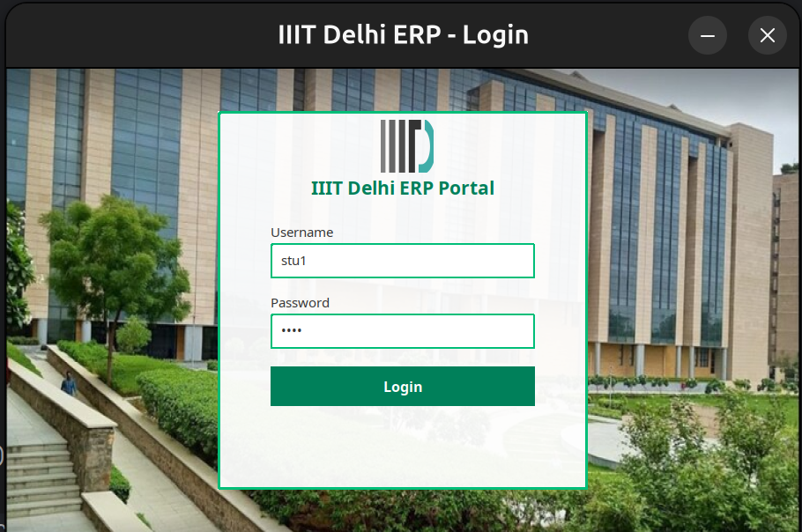
  - Admin: this panel will be used by the admin to add/ delete / edit various field such as the courses , sections , users as well as the admin has the maintenance toggle which will enable and disable the maintenance mode, which will restrict the student and the instructor to update anything. This is the screenshot of the admin 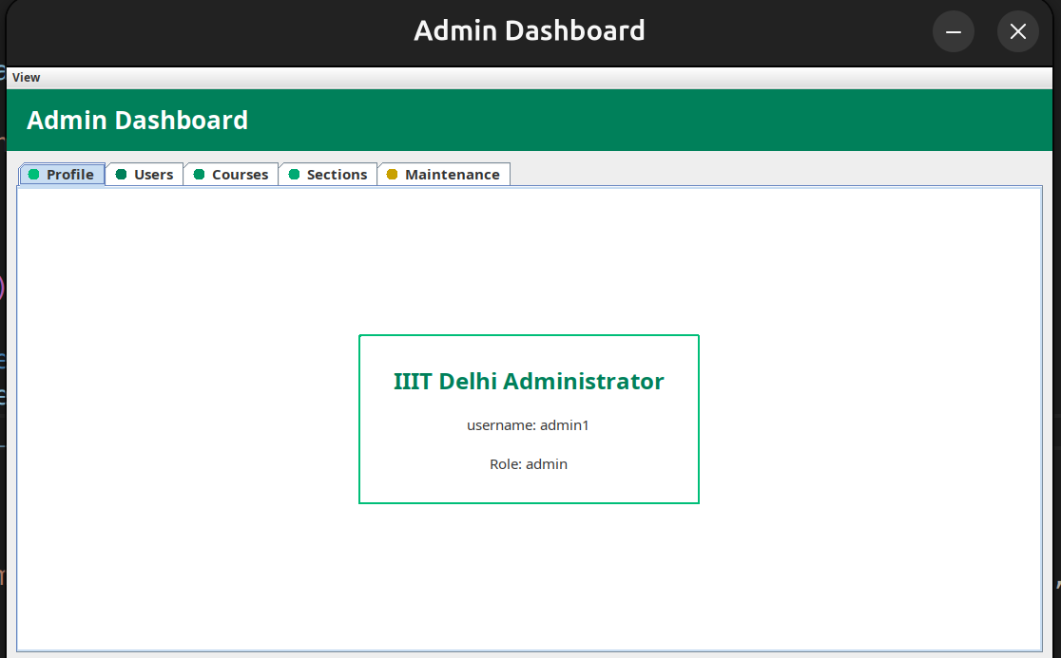
  - Instrucotors: this panel is used by the instrucotors to see sections which they are teaching and see / edit the grades of the students who are enrolled in the section and have a profile panel where the instrucotor can see the user information(not Password).these are the screenshot of instructor.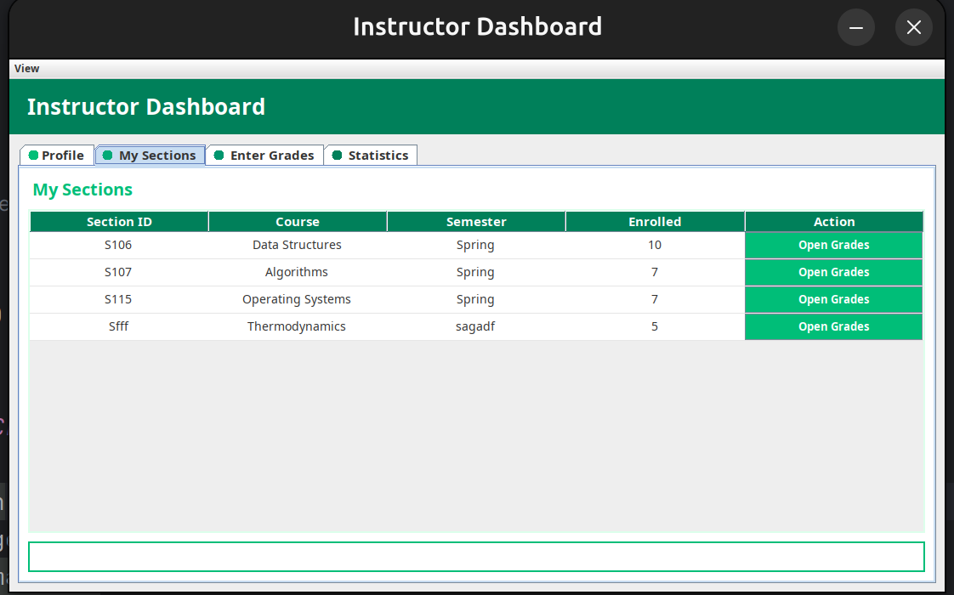
  - Students: this panel will be used the most as it is the student panel , it contain pages like the catalog, from where student can register there sections , and my registration from where student can see theer currently registered sections , from there they can also drop the sections if they want to lastly we have the grades panel and the profile panel , which show there grades of the sections in which they are enrolled in and the profile panel which show there user information (not Password).
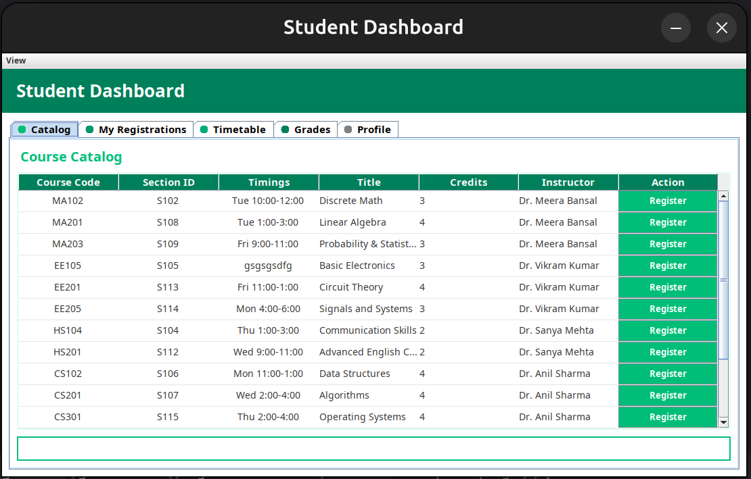
- Overview of Frontend : For the frontend of our ERP project, we used pure Java Swing and kept the entire interface clean, simple, and modular exactly as recommended in the assignment.All three panels Admin, Instructor, and Student extend a common BaseDashboard class so that the theme, layout, colors, icons, and table styling remain consistent everywhere. The UI is mainly built using JFrame, JPanel, JTabbedPane, JTable, JScrollPane, JButton, JTextField, and JOptionPane. We purposely avoided any external UI libraries and used only Swing’s layouts like GridBagLayout, BorderLayout, and GridLayout to manage the screens.This helped keep the interface lightweight and ensure that everything works smoothly without requiring anything outside standard Java.

- Login screen: The login screen is made using a simple JFrame with text fields for username and password.

- Admin panel: In the admin dashboard, we designed four main sections: Users, Courses, Sections, and Maintenance.All of these use JTable with DefaultTableModel to display and manage data. The Edit and Delete actions are implemented using custom button renderers inside the table cells, and every action opens a small popup form using JOptionPane for adding or editing entries. Adding a user or course is handled in a form-style popup, where we collect the necessary fields and pass them to the backend. For deletion, the table row is removed visually only if the backend confirms the delete.

- Instructor panel : The instructor dashboard also follows a clean and simple design. It has a profile page, a page showing the sections assigned to the instructor, and a grade entry page. In the grade page, instructors can load students of a section and edit their marks directly inside the JTable. The highest, lowest, and average marks are calculated live through a TableModelListener so the instructor instantly sees updated statistics without needing any graph or complex visuals.

- This matched the assignment requirement of having basic grade statistics without extra visualization libraries. Saving grades triggers only one backend call, while the frontend handles all UI feedback.

- Student panel : The student dashboard is the most interactive one. The catalog page lets students register for sections, where the Register button is again a table cell editor. If a student is already registered, the UI shows a toast-style message. We also integrated maintenance mode in the student portal: when maintenance is ON, all registers and drops become visually disabled and also blocked functionally.

- My Registrations uses a similar table structure with a Drop button. The timetable page is made using a simple 6×6 grid of JLabels.
- The Grades page shows all grade components and includes a feature to download the transcript in CSV or PDF format

